LAB REPORT - EXPERIMENT 4

COEN 316 – Computer Architecture – Winter 2025
Section WC - X

Lab performed on : April 2th 2025
Report submitted on : April 16th 2025

Lab performed and report written by : Simon Guindon – 40058301

TA Instructor:
Umair Hussain

Introduction and Objective
This experiment’s objective is to combine the different units that were made in lab 1 – 3 (namely the ALU, the Regfile and the next_address logic units) and add the remaining units to create a fully functional CPU that can run MIPS assembly code stored in the instruction cache. For the purposes of this lab, my code is divided into 8 distinct sections labelled A to H. The first part of this lab was meant to introduce the data path of the signals, and the second part was meant to introduce the control signals that will bind the CPU together.
Theory and Results
The usefulness of dividing the CPU into 8 different segments for coding was useful to adequately compartmentalize the code to respond to a variety of opcodes. Depending on the 32-bits instruction in assembly code written in the instruction cache, the system will properly respond to update the PC, regfile and memory appropriately. For the Data path, we has to fill in the gaps in this incomplete figure:
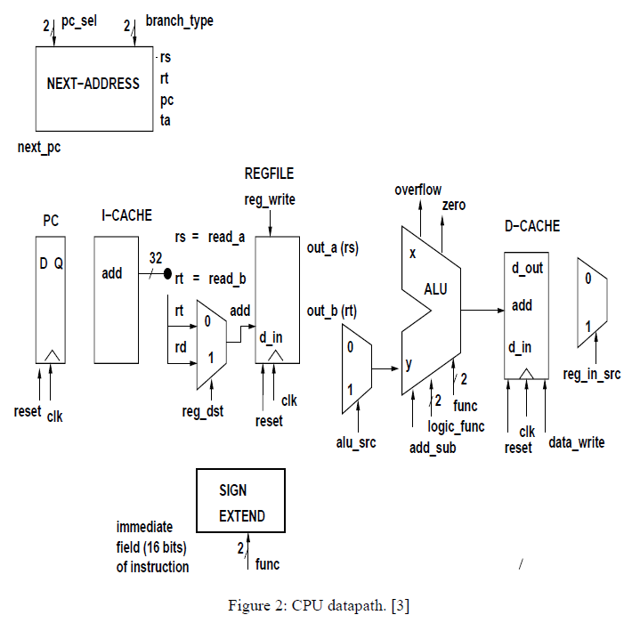
For the Control unit, we has to fill in the following figure with all appropriate signals to perform the opcode as expected:
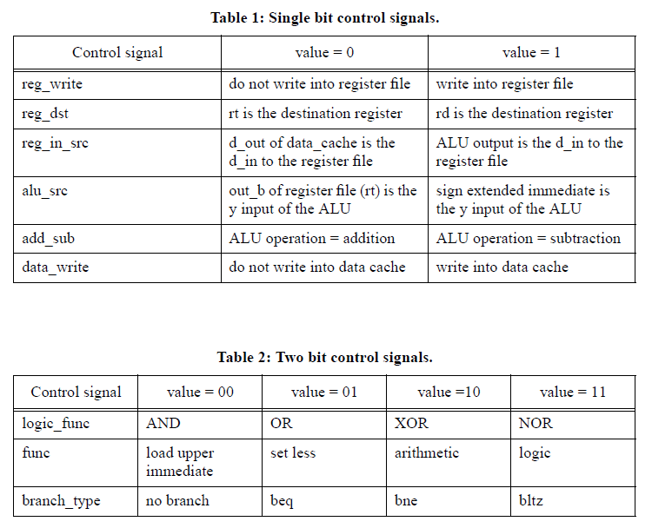
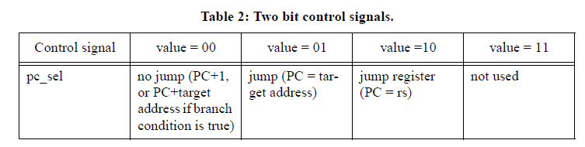
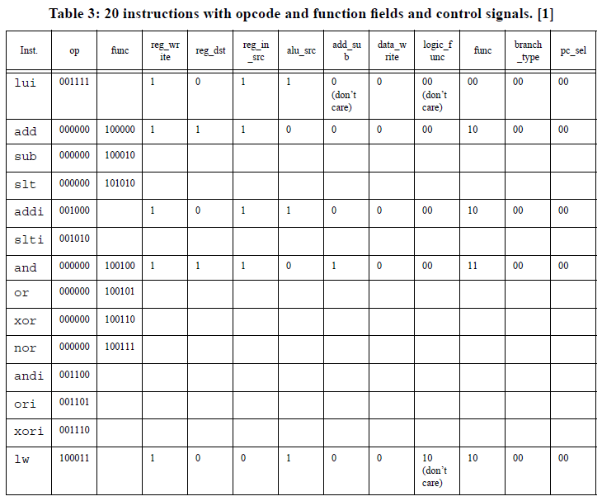
Results
The Figure below is what I used to built my code :
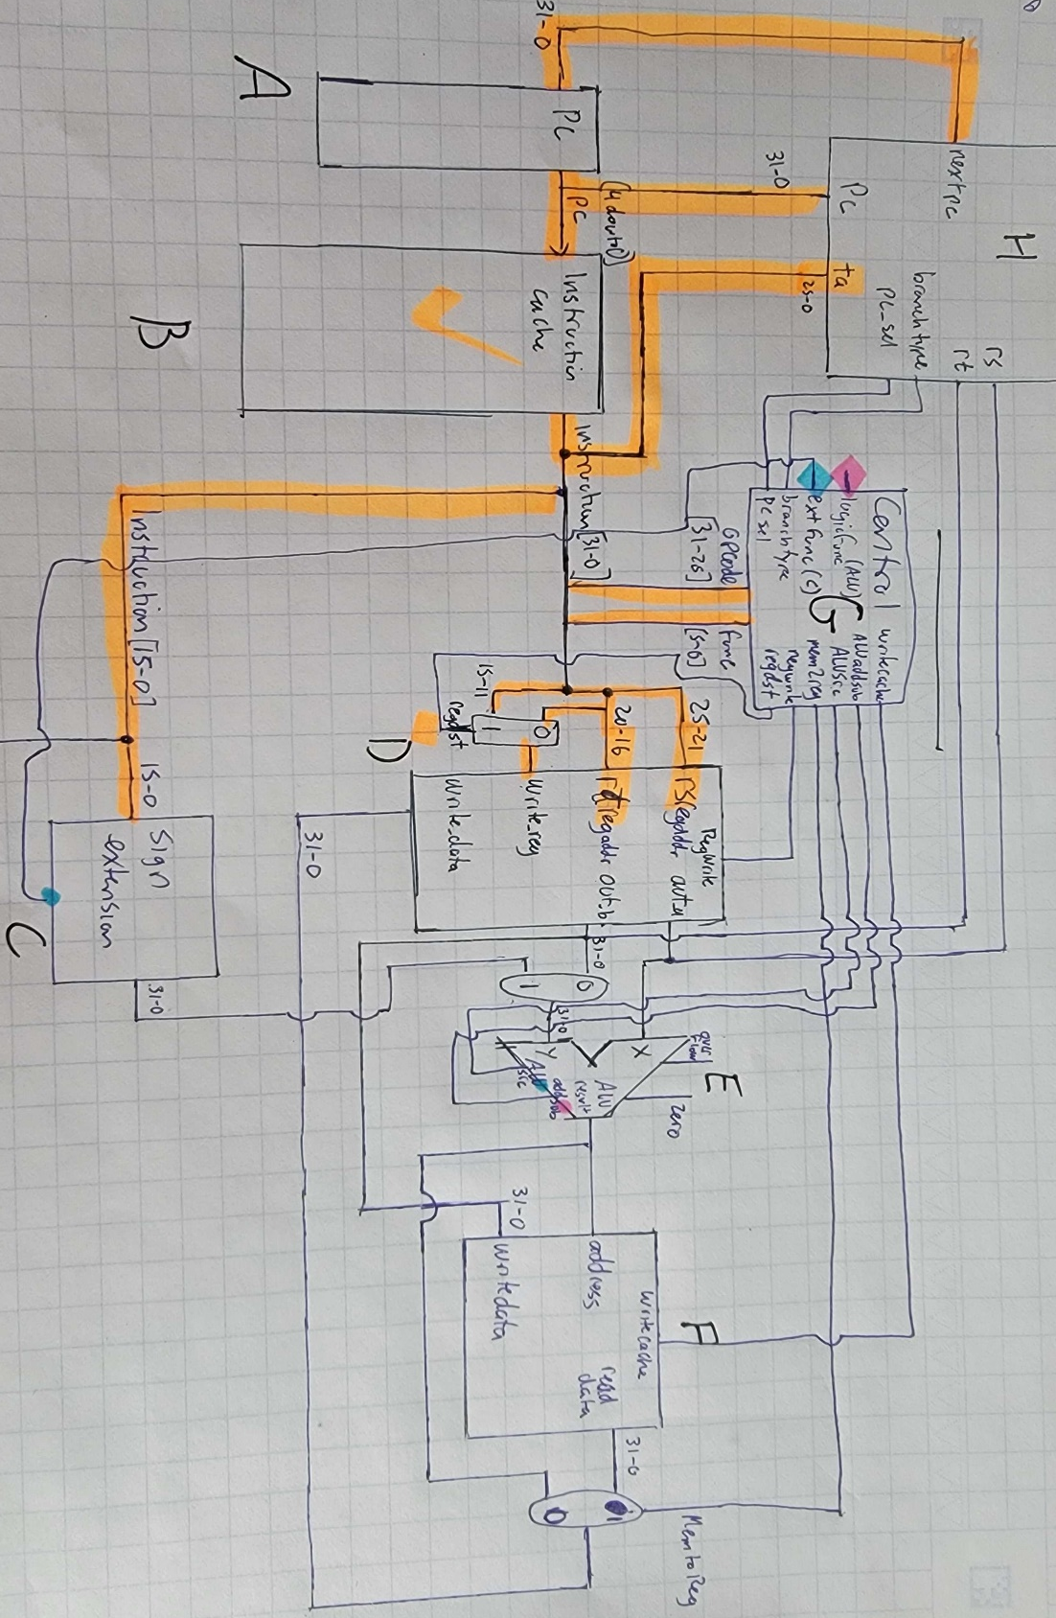

Section 1.1 – Testing ModelSim’s output for cpu.vhd
For this section, we need to test the following MIPS assembly opcodes (as seen in the comments part):
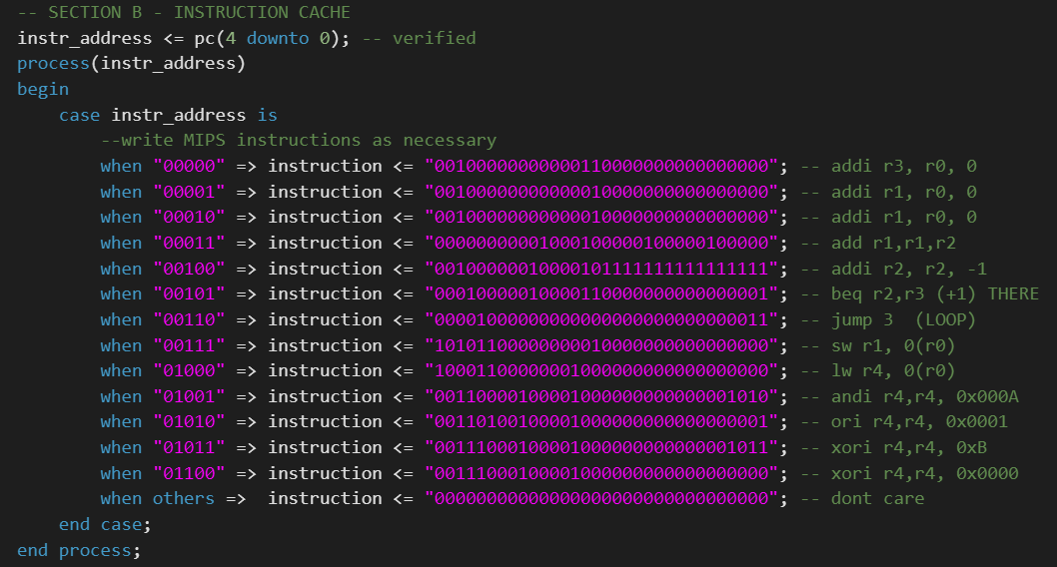
Figure 1 – ModelSim results for the instructions 00000 to 01100:
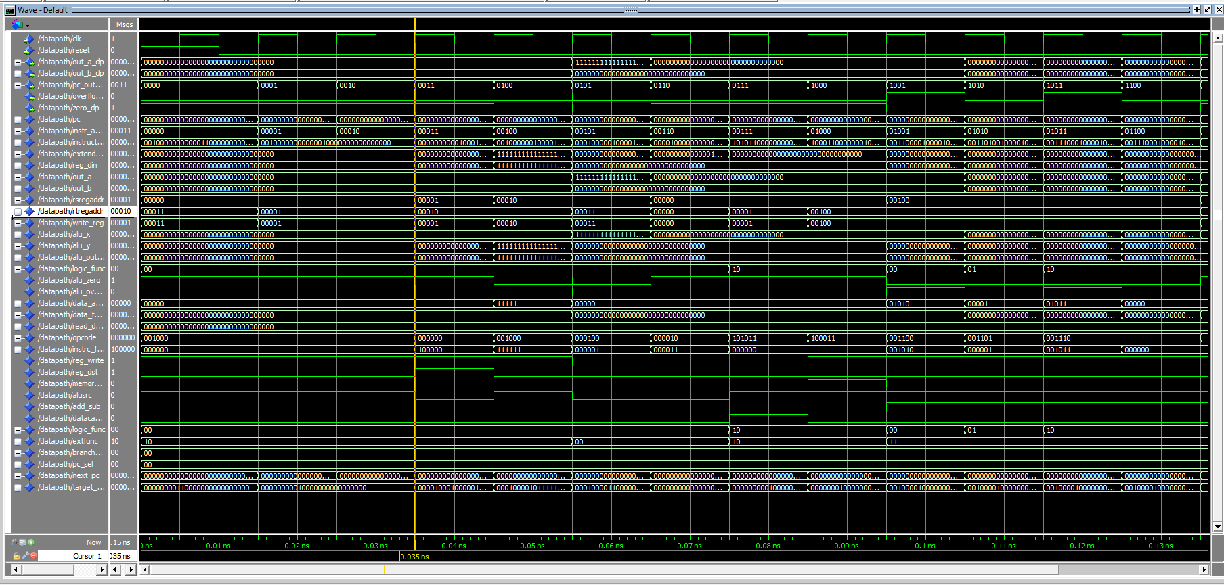

To show that the control signals behave as expected:
- logic_func is correctly 00 when AND, 01 when OR, 10 when XOR, 11 when NOR.
- branch_type is correctly 00 when no branch, 01 when beq, 10 when bne and 11 when bltz
- extfunc (func) is correctly 00 when load upper immediate, 01 when set less, 10 when arithmetic and 11 for logic.
- reg_write is correctly 0 when registers are not written in, 1 when they are.
- reg_dst correctly goes to 1 if rd is destination register, else is 0 for rt.
- memory_to_reg is correctly 0 when data cache is din of regfile, correctly 1 when ALU output is din of regfile.
- alu_src is correctly 0 when out_b is used as y input into ALU, or 1 when the extended immediate is used as y.
- add_sub is correctly 0 when adding, 1 when substracting
- data_write is correctly 0 when data cache is not written into or 1 when it is (during sw opcode).
- pc_sel is correctly 00 when no jump, 01 when jump with target, 10 when jump with register.
The 20 opcodes and their function fields/control signals are shown below:
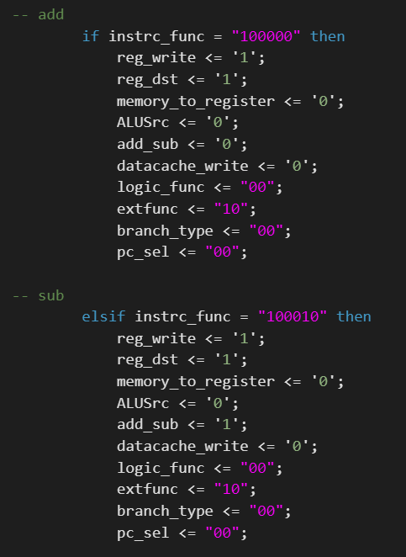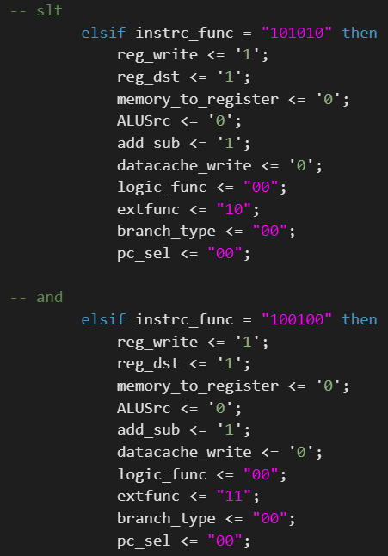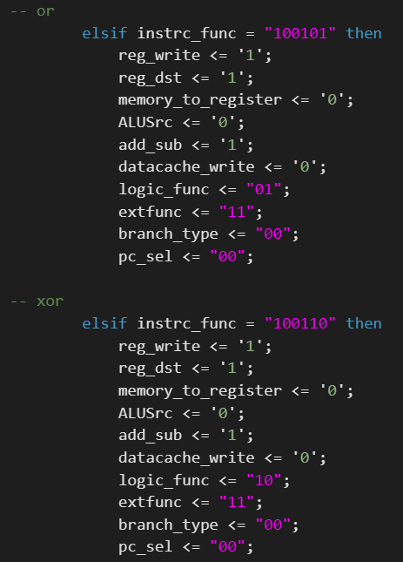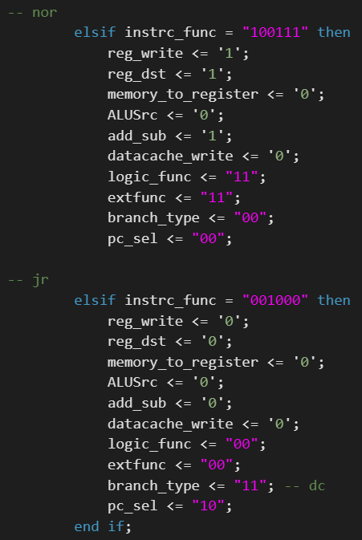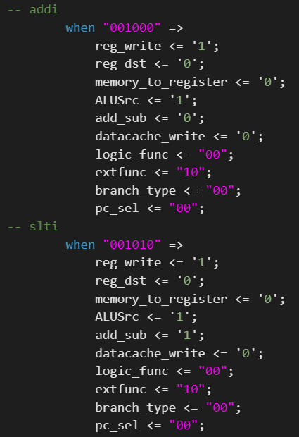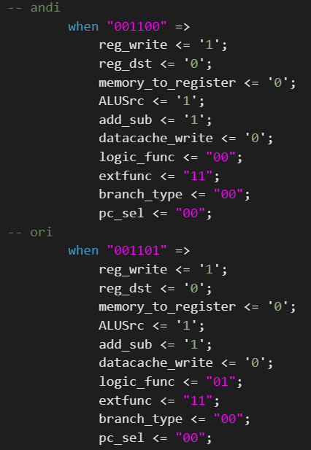
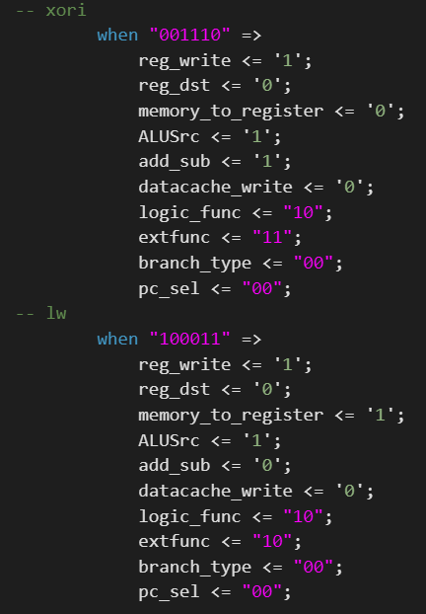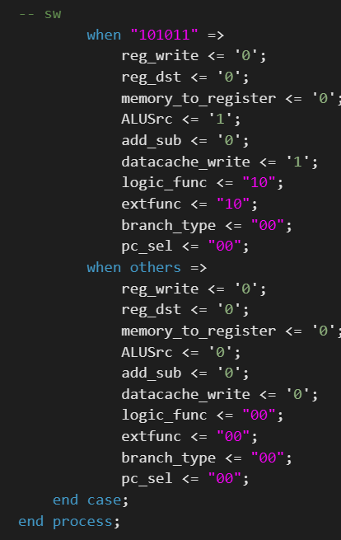
Section 2.1 – VHDL source code for cpu.vhd
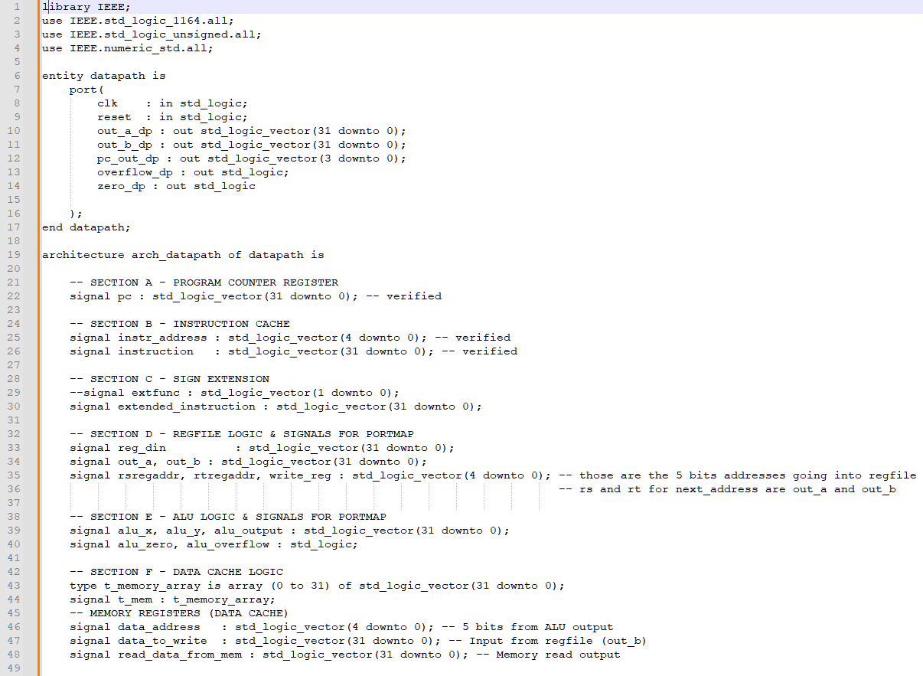
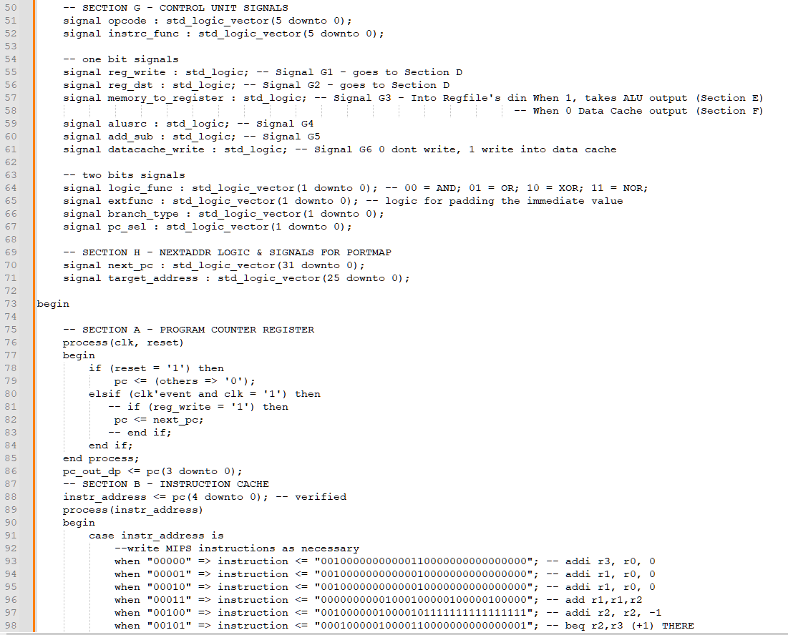
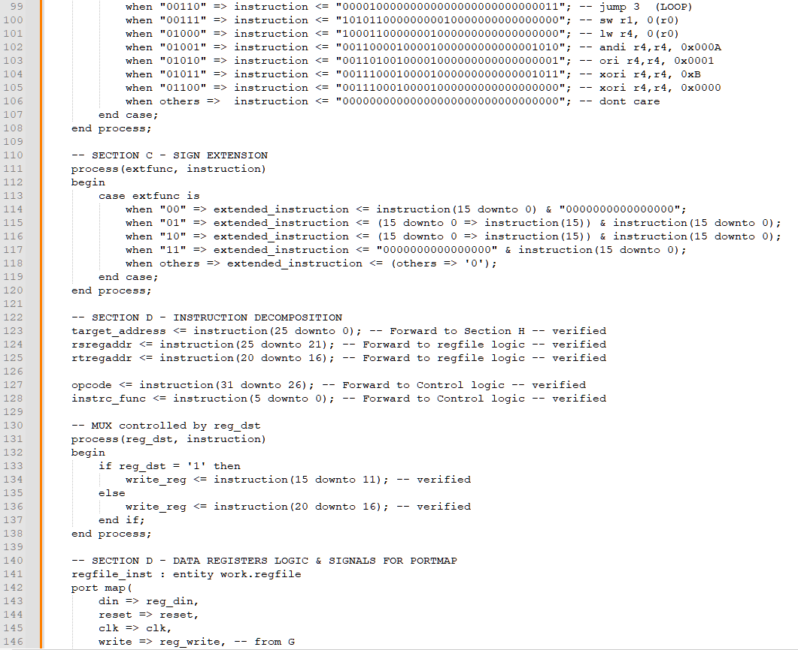
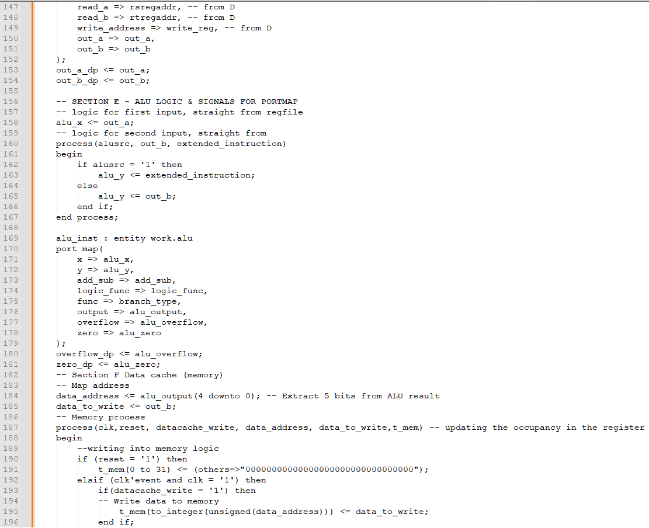
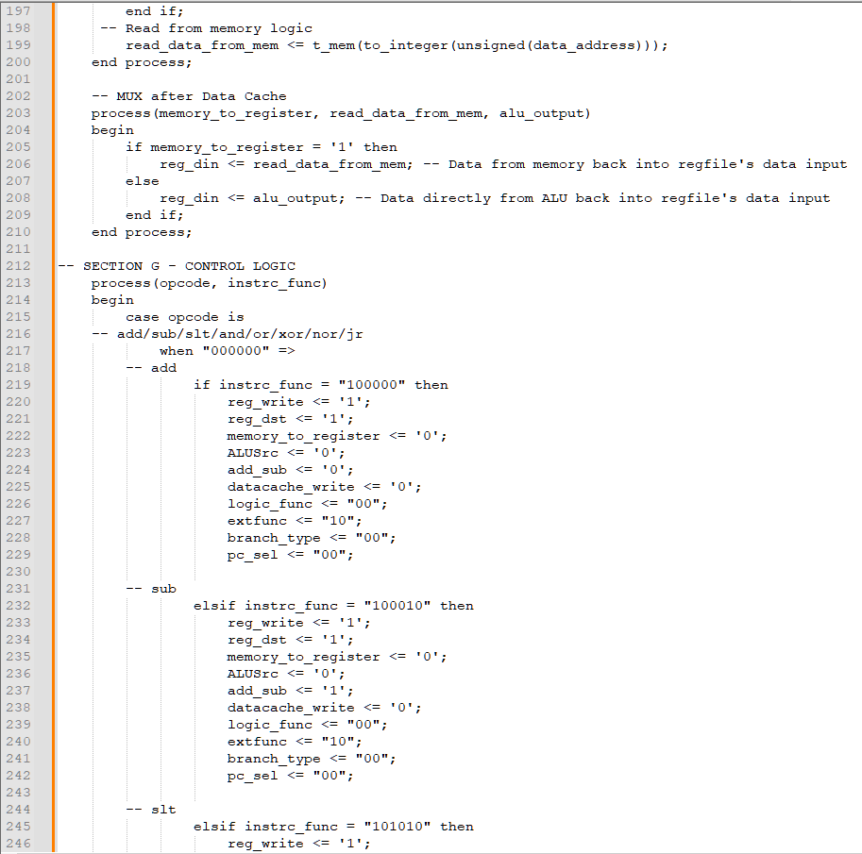
Note, OPCodes/Control logic were shown above and wont be shown again here
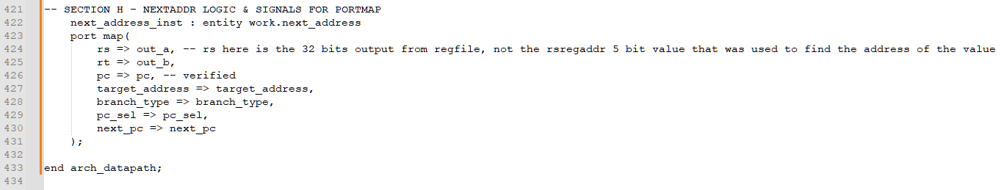
Section 3.1 – Do file for cpu.do
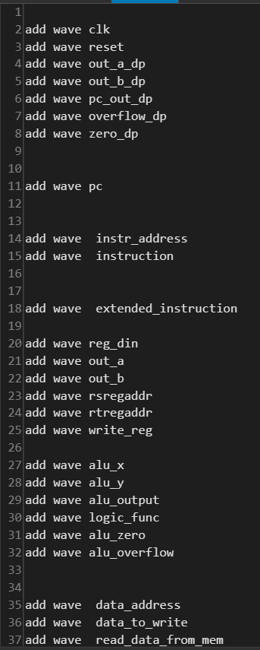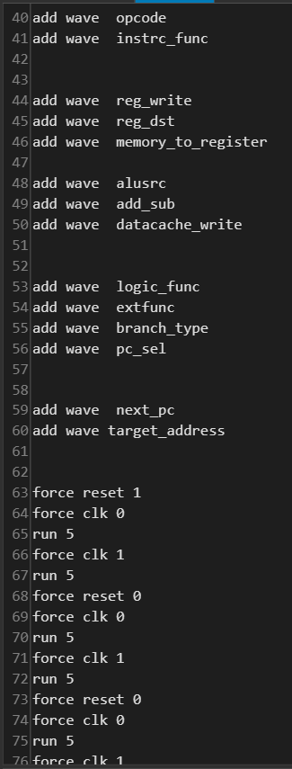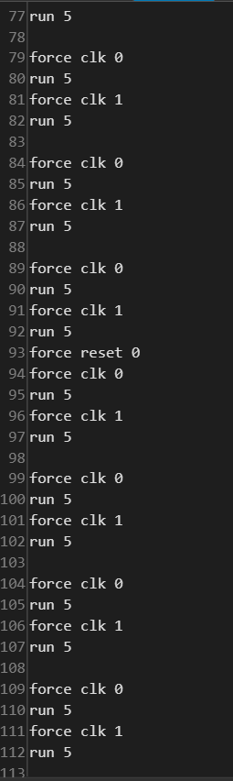

Section 3.3 – XDC file for cpu.xdc
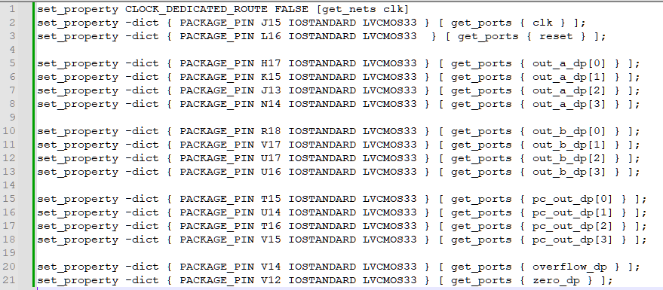
Conclusion
In conclusion we had our first experience of building a completely functional CPU that can be presented and implemented on a Nexys A7 board. The results we obtained in the simulation environment were in agreement with the theoretical values for the CPU’s control signal and data path.

Question 1) Since the Utilization percentage for one CPU is ranging from under 1% (for everything that is not the SLICEL and SLICEM), and 3% for SLICEM/SLICEL, 5 10 and 20 CPU work be able to be implemented in the boards (capping at 20% and 60% for 20 CPUs)
However, 100 would not be doable because 300% util would occur for SLICE L and SLICE M.

Question 2) The other limitations other than the resource usage as seen above, we are limited by timings, scalability and compatibility.

